Professor: Mohamed Dakroury

2022/2023

project team:

Ahmed Shaaban (1)

Youssef Abo Baker (3)

Youssef Marawan (3)

Faculty of engineering

**Voltmeter**

**Introduction:**

The using of a voltameter is a common method for measuring voltage. A voltameter is a device that measures voltage by converting it to a readable form, typically using a digital display. While there are many commercial voltameters available, building a voltameter can be a rewarding project for electronics enthusiasts.

In this report, we will discuss the design, assembly, and testing of a voltameter project using IC7107 with a PCB and Proteus software. The IC7107 is a high-precision analog-to-digital converter that can accurately measure voltage levels and convert them to a readable format. The use of a PCB and Proteus software makes the process of designing and testing the circuit much simpler and reduces the risk of errors.

This report will provide step-by-step instructions for designing the circuit, creating the PCB layout, assembling the circuit, and testing its functionality. The project is designed to be accessible for individuals with varying levels of electronics experience, and the required materials and components are readily available and affordable.

Overall, this project provides a valuable learning experience for electronics enthusiasts interested in designing and building their circuits. The voltameter using IC7107 with PCB and Proteus software is an excellent example of how modern design tools can be used to create useful circuits for a variety of applications.

**Circuit components and their functions:**

**IC7107:** is a 3.5 digit A/D converter that is used to measure the input voltage and convert it into a digital signal. It provides accurate and stable readings of voltage.

**Resistors:** A 10Ω resistor is used to limit the current flow through the LED.

**Capacitors:** A 0.1μF capacitor is used for smoothing and filtering the input voltage.

**7-segment:** is used to indicate the voltage measured by the circuit.

**Potentiometer:** A 20kΩ potentiometer is used to calibrate the circuit and adjust the voltage range.

**Breadboard or PCB:** is required to hold the components and make connections between them.

**Connecting wires:** are required for making connections between components.

**Power supply:** is required to provide power to the circuit.

**The circuit diagram for the voltameter is shown below:**

In this circuit, the input voltage is fed to the Vin+ and Vin- terminals of the IC7107. The voltage is amplified and converted into a digital signal, which is then displayed on the 7-segment. The 20kΩ potentiometer is used for calibrating the circuit and adjusting the voltage range.

**PCB Layout:**

The PCB layout is a crucial aspect of any electronic circuit design. It determines the physical arrangement of the components and the routing of the traces. The use of a PCB not only makes the circuit more compact but also reduces the risk of errors and improves the overall performance.

**The following is an image of the PCB layout for the voltameter:**

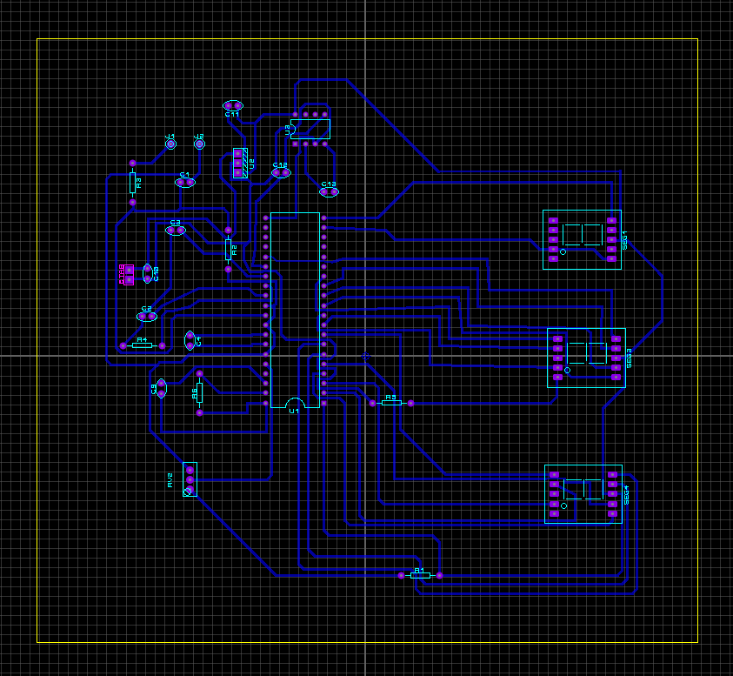

The PCB layout is designed to be compact and easy to assemble. It has been optimized to reduce the length of the traces and minimize interference. The PCB can be easily assembled by soldering the components to the board according to the layout. Once the PCB is assembled, it can be tested and calibrated according to the instructions provided in the previous sections.

**Assembly and Testing:**

Once the PCB layout is complete and the PCB is fabricated, the assembly process can begin.

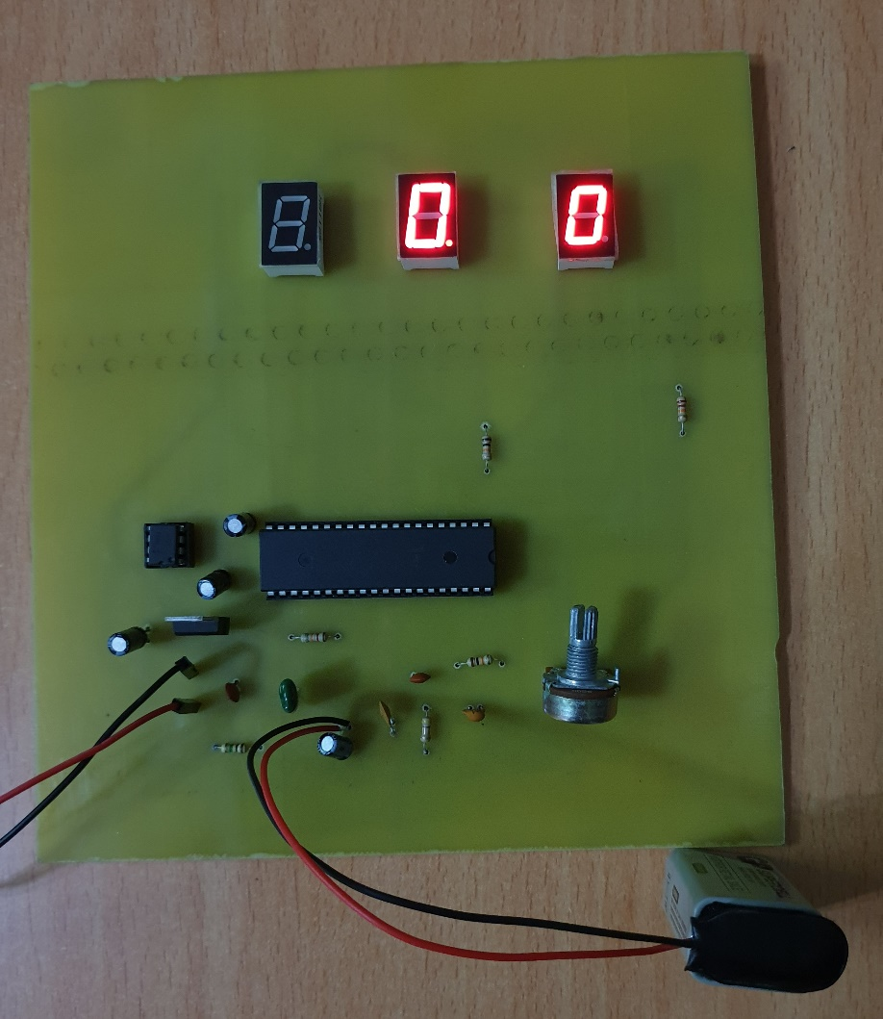**The following is an image of the PCB for the voltameter:**

Once the circuit is verified to be working correctly, the voltameter is ready to be used.

It is important to follow safety precautions when assembling and testing the circuit. Avoid touching the circuit while it is connected to a power supply and ensure that the power supply is properly rated for the circuit.